# Comparator Circuit

## Purpose:

The comparator circuit allows for the generation of logic-level signals from the analog output of the sensor used to detect blade passes. These logic-level signals are used as external interrupt signals to the Arduino. Together with the Motor Testing Program, this allows measurement of motor RPM.

## Parts:

|  |  |  |  |
| --- | --- | --- | --- |
| *Name/Description* | *Part No.* | *Qty.* | *Label* |
| 10 kΩ Resistor (5%) | NA | 4 | R2, R4, R5, |
| 15 kΩ Resistor (5%) | NA | 1 | R1, |
| 220 Ω Resistor (5%) (NOTE: CONSIDER INCREASING THIS RESISTOR VALUE TO LIMIT CURRENT. WE DID NOT TEST THIS HOWEVER.) | NA | 1 | RS, |
| 22 kΩ Resistor (5%) | NA | 1 | R3, |
| Comparator | Texas Instruments  *TLC372IP* or *TLV2352IP* or similar | 1 (Dual package) | U1A, and U1B, |
| 100 pF Capacitor (10%) | NA | 2 | C1, C2, |
| Ambient Light Sensor (photo-transistor) | Everlight  *ALS PDT144-6C-L451* or similar (sold by Radio Shack as “Ambient Light Sensor” ). | 1 | Q1, |

## Discussion:

Solderless breadboard construction should be adequate for most applications. See schematic (provided as a separate PDF document) for circuit connections. Exact values of R1, R2, and R3 may need to be adjusted for better performance depending on details of your application. These resistors provide “reference voltages” against which the signal voltage is compared. When the signal voltage is above the reference, the corresponding output is high (5 V) due to the pull-up resistors. When signal voltage is below reference, the corresponding output is pulled low (0 V). The following equations can be used to adjust reference voltages as needed to achieve good high speed interrupt signal generation. You may need to experiment with this, though the resistor values given here worked well in our application.

As an example of the completed circuit performance, the following screenshots were taken with a Rigol DS1102E oscilloscope.

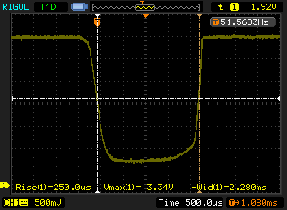

Figure 1. Raw signal output (VSensor), taken at 10% throttle (about 1550 RPM)

Note in Figure 1 the high frequency noise that is present in the signal. Also note the relatively smooth transitions from the high voltage (≈ 3.34 V) to the low voltage (≈ 0.5 V) state. This smooth transition can cause problems if the signal is to be used as an external interrupt to the Arduino. An early design used an analog measurement off of this signal, but was found too slow on the Arduino Uno for accurate high rpm measurements. The purpose of the comparator is to signal when the sensor voltage crosses certain thresholds, allowing more precise and consistent timing. Using two comparator levels allows the Uno to ensure that full voltage cycles (bright-dark-bright) are completed before counting a blade pass, eliminating problems created by high-frequency noise in the signal causing multiple crossings to be detected if only using one interrupt. Alternatives to the arrangement given here are certainly possible, so feel free to experiment!

When the circuit is working, the output of the comparator (Labeled “To High Interrupt Pin” and “To Low Interrupt Pin”) will look something like Figure 2.

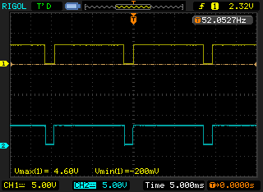

Figure 2. Comparator output, 10% Throttle, CH1: High interrupt, CH2: Low interrupt

Notice in Figure 2 that the output swings between 4.6 V and ground and makes the transition quite rapidly. Though not clear in Figure 2, the switching of the states of each output are not exactly synchronized. This is shown in Figures 3 and 4.

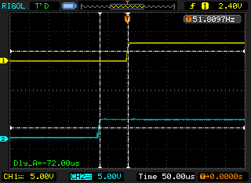

Figure 3. Comparator output rising relationship, CH1: High interrupt, CH2: Low interrupt

This timing difference is intentional and beneficial. Each change in logic level triggers an interrupt on the Uno, allowing the Motor Test Program to require that both interrupts occur in a defined order before a pulse is counted. Take a look at the Motor Testing Program code to better understand how this process works. Using both interrupts, which each correspond to different voltage levels of the phototransistor, we are able to ensure that small voltage deviations do not cause extra pulses to be counted. This allows more more accurate counting of blade passes and thus rpm.

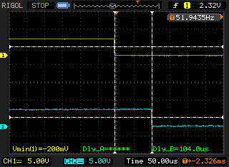

Figure 4. Comparator output falling relationship, CH1: High interrupt, CH2: Low interrupt

The change in delay during rising and falling states can be attributed to the differing slopes of the signal as it falls and then rises during blade passing events as seen in Figure 1.

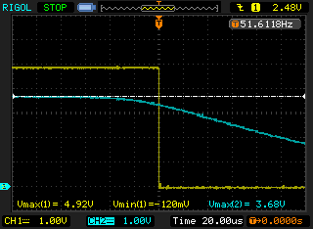

Figure 5. Comparator output versus raw sensor, CH1: High interrupt, CH2: Sensor signal

Figure 5 illustrates the difference between the raw sensor data and the comparator output. Notice the large difference in the slope of the two signals as they fall. This “sharpness” of the comparator output makes it function much better as an external interrupt signal to the Arduino.

## Circuit pictures and tips:

A few pictures of the circuit on a solderless breadboard are provided here for a general idea of layout, but you’re crazy if you try to create the circuit based on these pictures! This circuit was assembled just to photograph for this guide, and for a more permanent application it would definitely be advisable to relocate some of the resistors to minimize the chance of an unexpected short occurring during testing. Also, one of the two filter capacitors (C2) was not added to the circuit in this picture. In testing, the interrupt routine functioned well with only C1, though we still recommend installing C2 for more reliable performance.

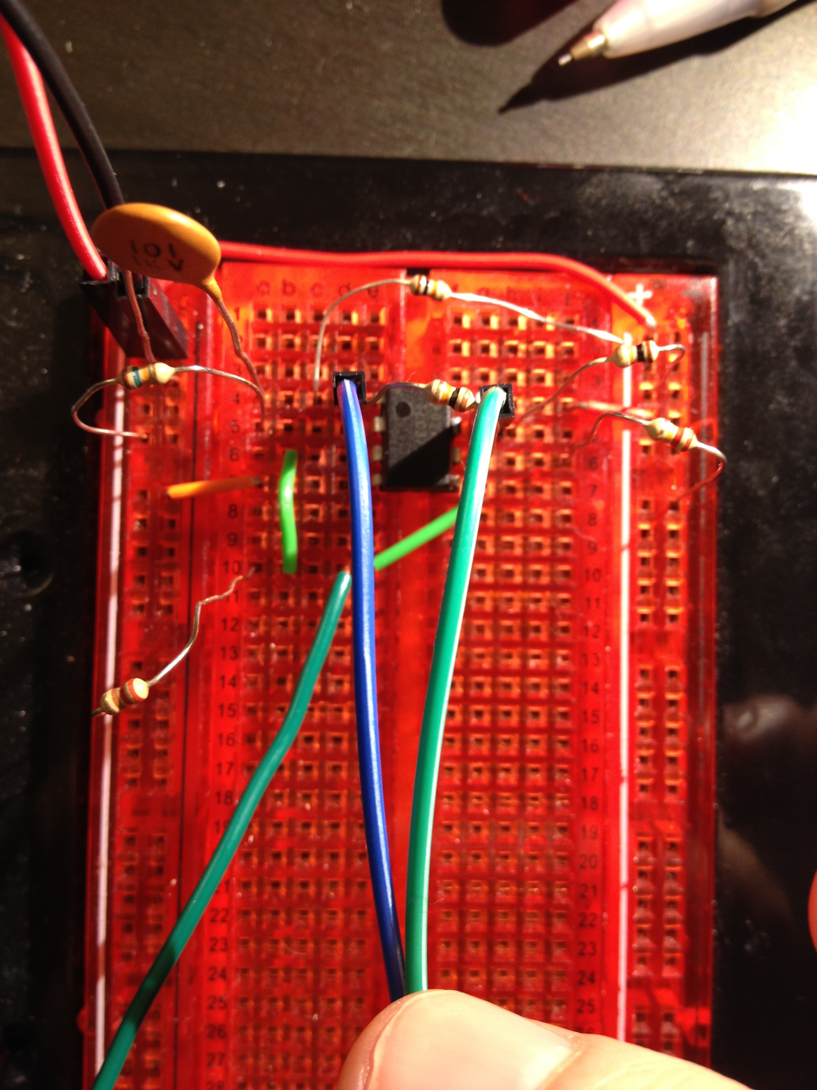

Figure 6. Comparator circuit on a solderless prototyping board.

In Figure 6, the blue and green center wires carry the interrupt signal to the Arduino. The green wire coming from the bottom left carries the sensor signal from the phototransistor.

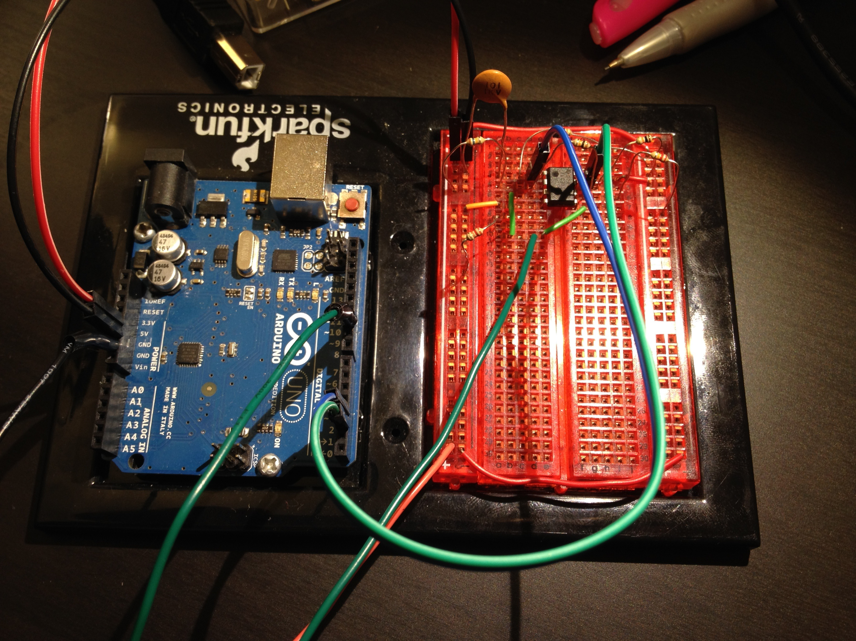

Figure 7. Another view of comparator circuit on a solderless prototyping board

In Figure 7, the signal and ground wires to the ESC are also visible. As previously mentioned, these photos are only for general overview of what to expect, and shouldn’t be used to construct the circuit.

